Publishing

* Advertising
* First framework: UDDI (Universal Description, Discovery, and Integration)

UDDI

* 2000
* Ariba, Microsoft, IBM
* Now managed by OASIS
  + Organization for the Advancement of Structured Information Standards

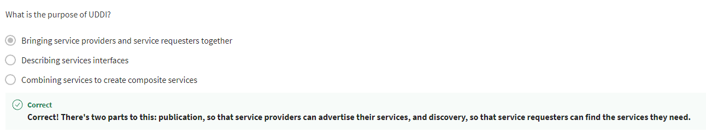

How UDDI is used:

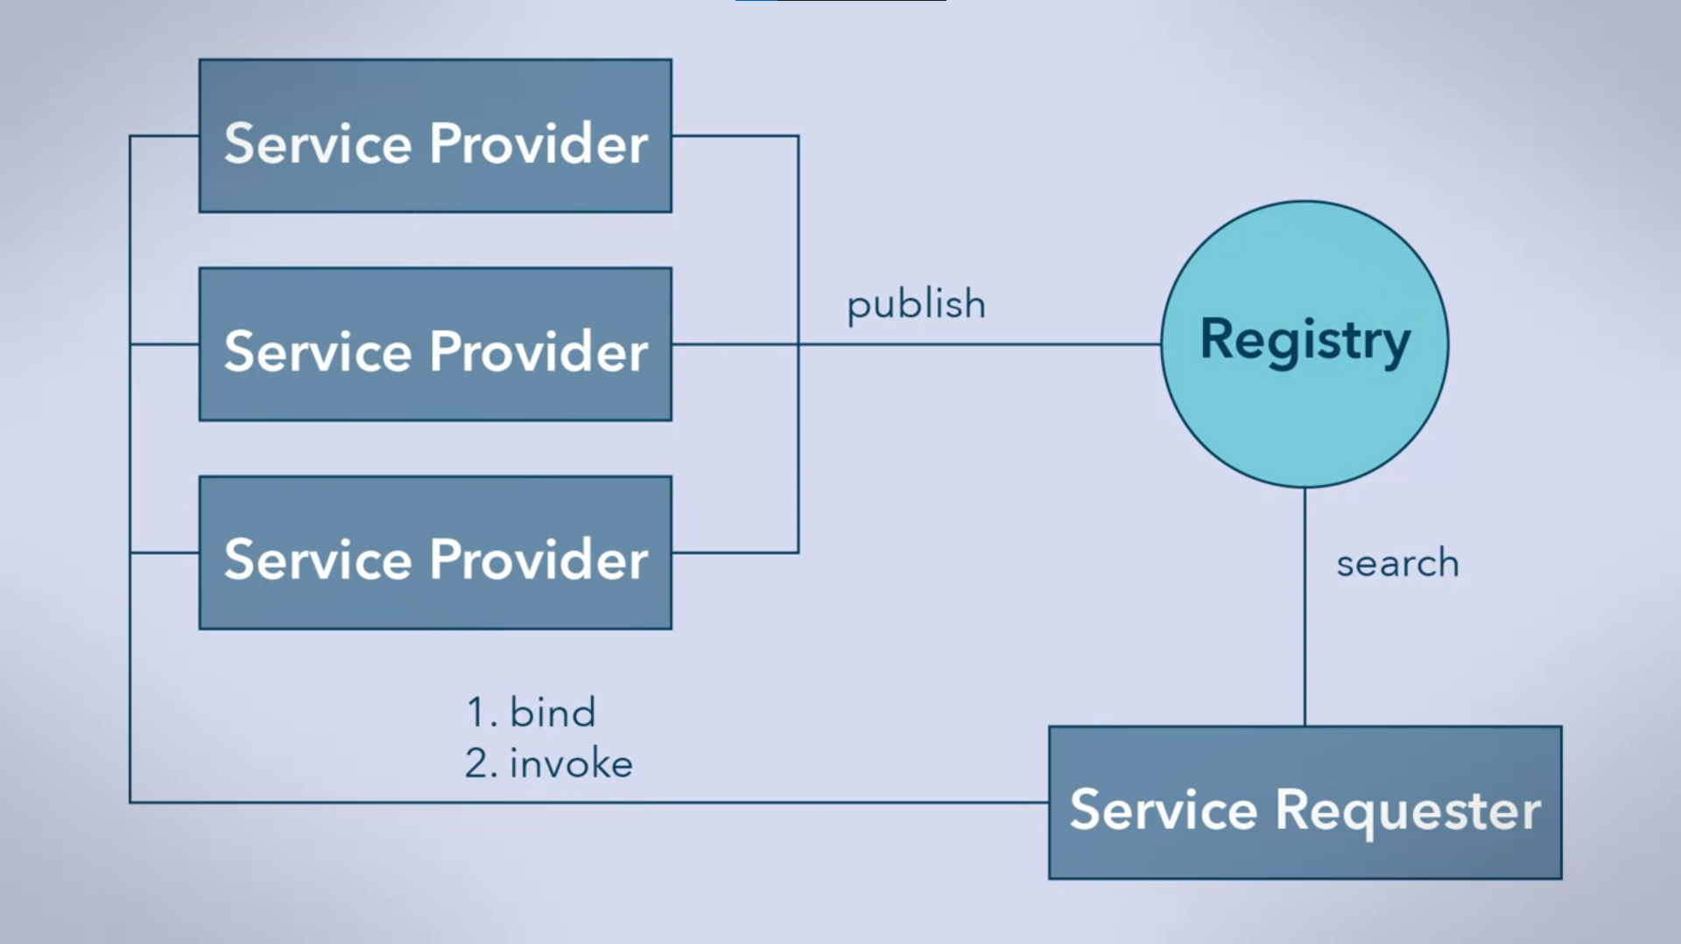

UDDI Registry

* Assigns the service a URI (Uniform Resource Identifier)
* 3 Categories
  + White Pages
    - Business
    - Short description
    - Contact information
    - Unique business number
  + Yellow Pages
    - Industry information
  + Green Pages
    - How to use the service



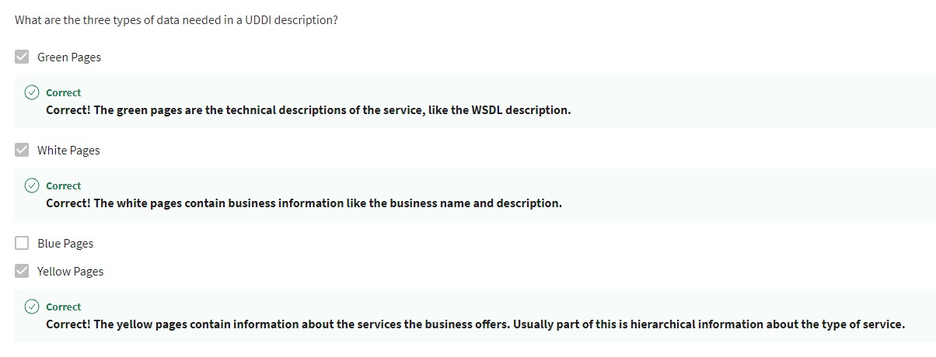

4 Data Structures of Registry

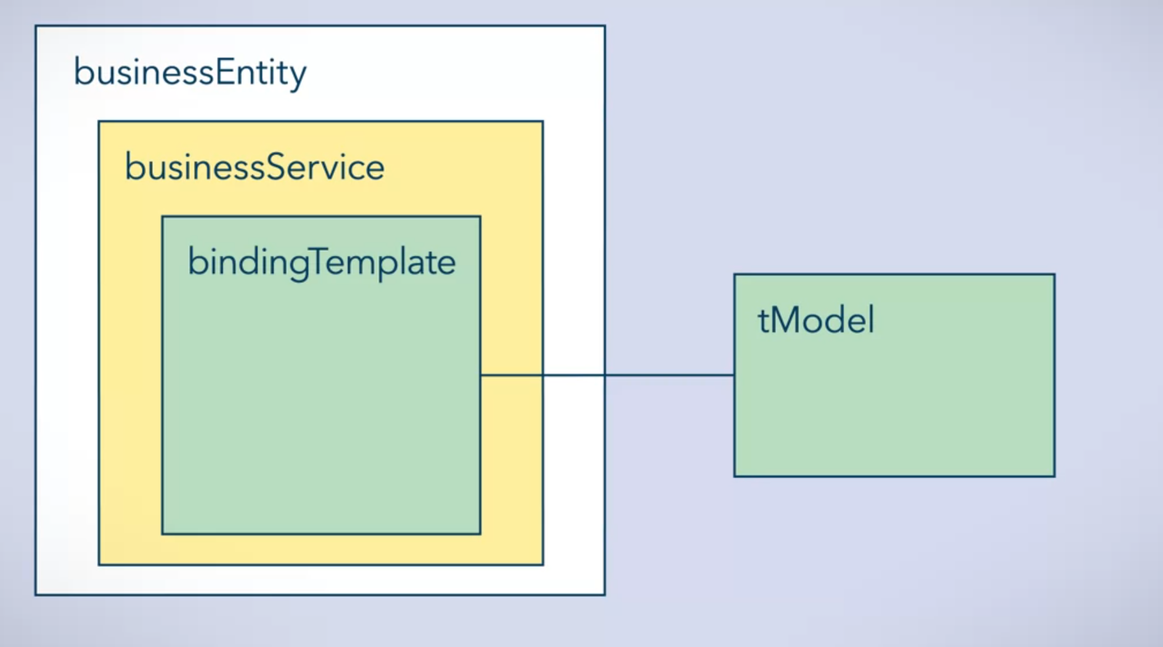

Service providers can:

* Add
* Delete
* Modify

In the registry

Sample commands:

Publish



Searching

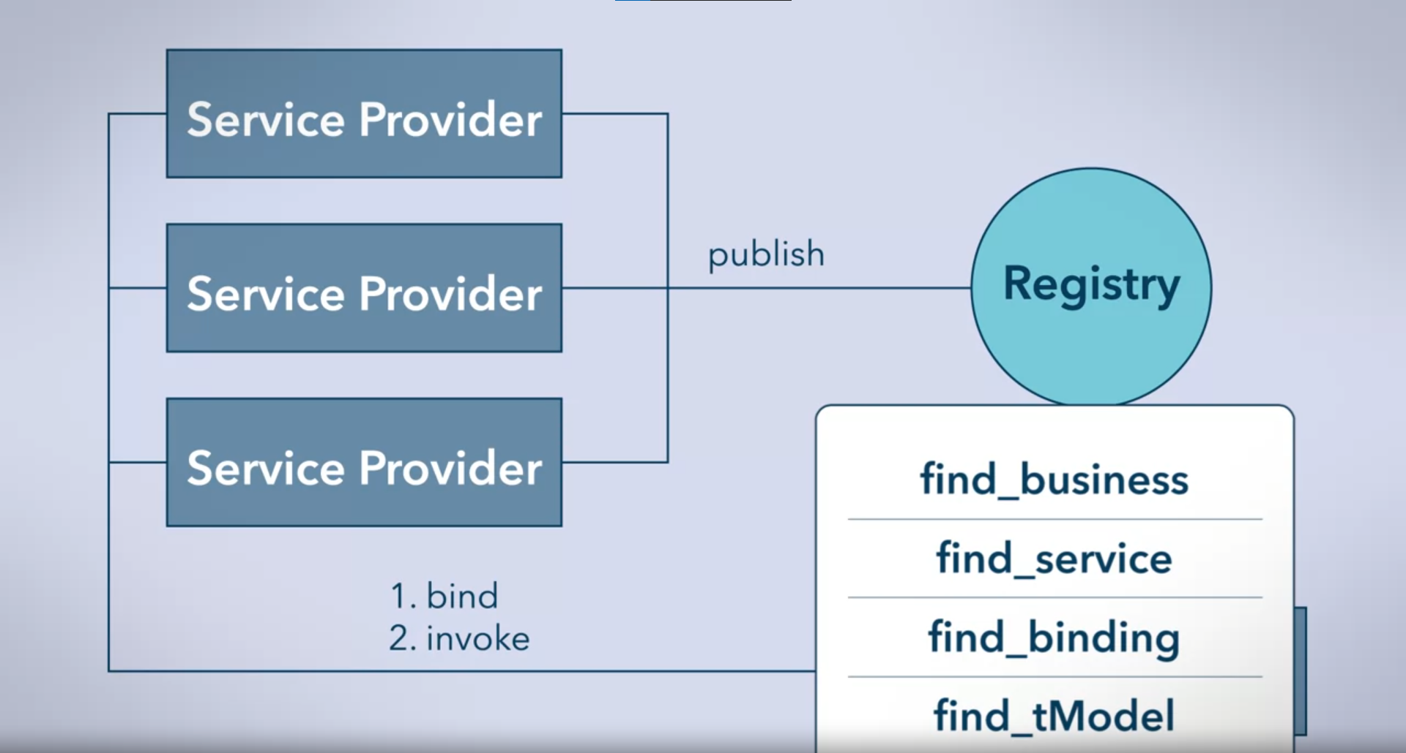

Requesting

